
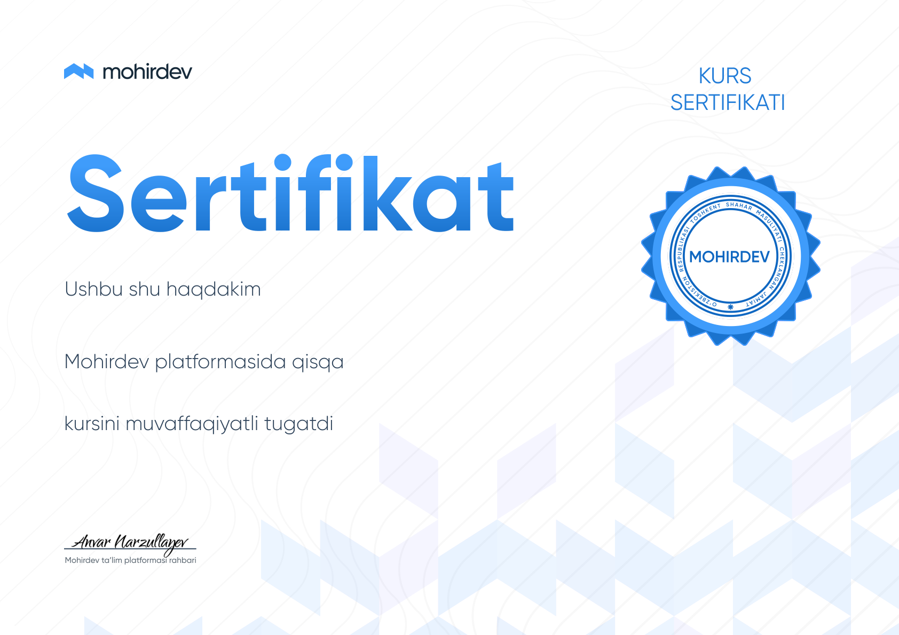


kurs
sertifikati
Sertifikat
Ushbu shu haqdakim
Xushnudbek Jumaboyev
Mohirdev platformasida qisqa
MERN orqali Travel Book fullstack application yozamiz
kursini muvaffaqiyatli tugatdi
Mohirdev ta’lim platformasi rahbari
17.09.2026
ID prac-60e56596

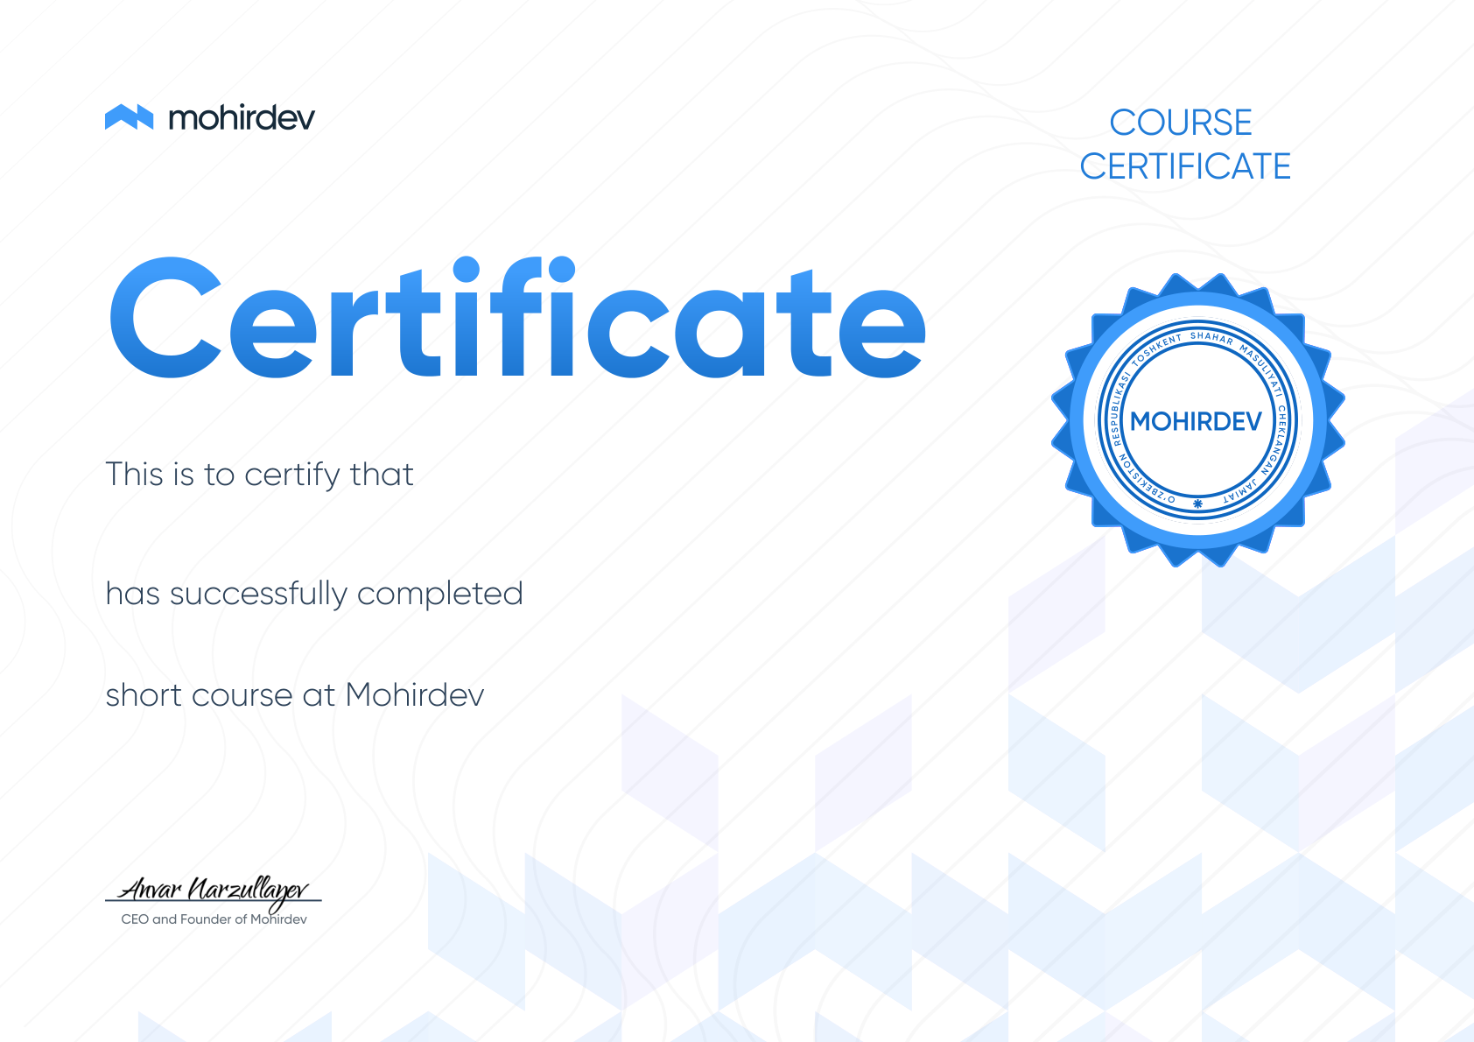
course
certificate
Certificate
This is to certify that
Xushnudbek Jumaboyev
has successfully completed
MERN orqali Travel Book fullstack application yozamiz
short course at Mohirdev
CEO and Founder of Mohirdev
17.09.2026
ID prac-60e56596

